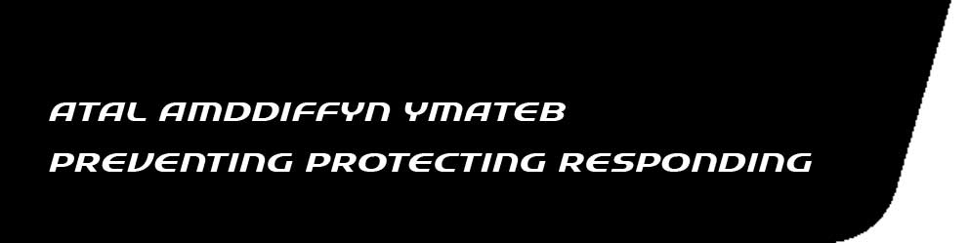

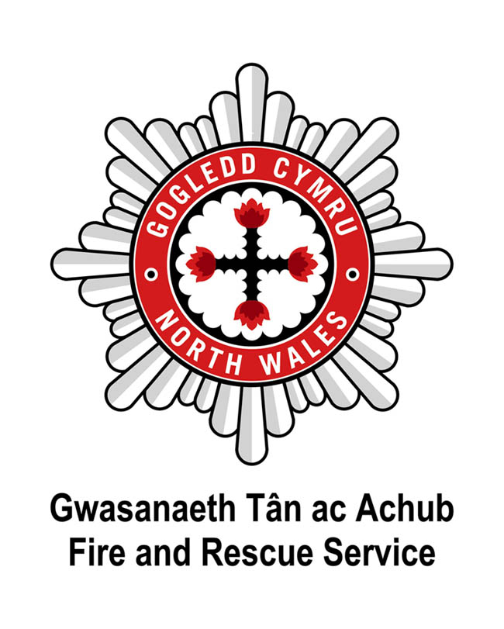

Dear Applicant

STATION MANAGER APPLICATION PACK

I have pleasure in enclosing the application pack for the vacancies of Station Manager.
North Wales Fire and Rescue Service is an equal opportunities employer and would like to have a workforce representative of the communities that we serve.
Completed application forms are to be returned via post to the address below or via email to HRDesk@nwales-fireservice.org.uk (forms received via email do not require a wet signature) no later than 12 noon, Wednesday 19th June 2019.
FAO Nicola Jones
(Application form for Station Manager)
North Wales Fire and Rescue Service Headquarters
Ffordd Salesbury
St Asaph Business Park
St Asaph
Denbighshire
LL17 0JJ
Applications received after the closing date will not be considered.
Please do not submit your CV with your application form, as only the information provided within the application form will be used at the shortlist stage.
We look forward to hearing from you and wish you well with your application.
Regards

The Recruitment Team

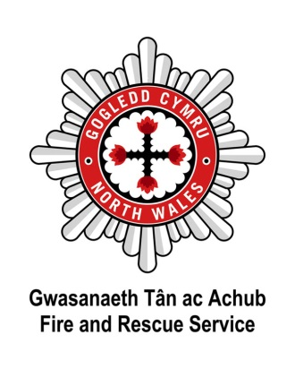

APPLICATION PACK
Station Manager

Contents

- Job Advert
- Welsh Language Scheme
- Role Map
- Recruitment Information Sheet
- Selection Information Sheet
- General Employment Conditions
- Application Form
- Equality Monitoring Form

Station Manager A/B (Flexi Duty)
Development to Competent
£47,248 to £52,113 per annum
(inclusive of allowances), plus lease car

North Wales Fire and Rescue Service (NWFRS) are seeking to appoint a number of Station Managers to our middle manager cohort. Applications are invited from substantive Station Managers wishing to transfer and substantive competent Watch Managers who have engaged with a Middle Manager ADC process within the UK Fire and Rescue Service.

The successful candidate will work in an increasingly demanding and performance centered environment. Applicants should have a strong track record of achievement and should understand and champion transformational leadership and be able to demonstrate a commitment to excellence.

Successful Applicants will provide operational cover on the flexi-duty rota and will be required to demonstrate operational competences at their current level.

Welsh Language skills are a requirement of this post and ideally candidates will be able to demonstrate Level 3 Welsh on application, however, this is not an essential selection criterion and full support and training will be provided to successful candidates to achieve Level 3 within a 12 month period.

Following evaluation of the application form, successful candidates will be invited to a selection process during the week beginning 22nd July 2019.

The results of the interview will be held for the next 12 months and used to fill any further vacancies occurring within that timeframe.

The successful candidate will be required to successfully undertake a Basic DBS check, medical assessment and reference checks.

For an informal discussion about this vacancy, please contact Area Manager Stuart Millington on 01745 535250. Application packs are available at www.nwales-fireservice.org.uk.

Closing date for receipt of application forms is 12 noon, 19th June 2019.

The closing date will be strictly adhered to and no exceptions will apply.

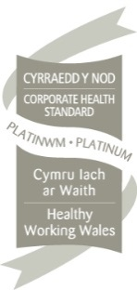
We are an equal opportunity employer and welcome applications from all sections of the community.

We welcome correspondence and calls in Welsh and English and we will respond
equally to both and will reply in your language of choice without delay.
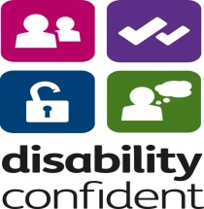

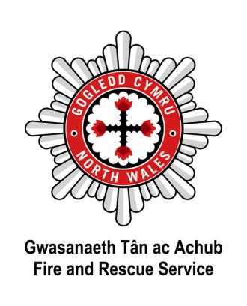
North Wales Fire and Rescue Service Welsh Language Scheme
At North Wales Fire and Rescue Service, we pride ourselves on having taken the issue of the Welsh language seriously over many years. By acknowledging our moral and legal duties to protect the cultural heritage of the area and to meet the expectations of the local community, we also acknowledge the positive service benefits of conducting our public business in both languages. Saving lives and reducing risk are at the heart of our mission - the language issue is vital to its success.
In accordance with statutory requirements, North Wales Fire and Rescue Service developed a Linguistic Skills Strategy to provide a means of responding appropriately to the Service's commitments contained in the Welsh Language Scheme.
As part of this Strategy, North Wales Fire and Rescue Service introduced the requirement for all new members of staff to have the ability to show basic Welsh language courtesy skills to at least Level 2. All new staff are allowed a specified period of time after formal appointment to achieve Level 2 standard.
Please note that Level 2 is the minimum requirement and that the assigned Welsh Language level for each post is listed in the Person Specification.
The minimum requirement for this post is Welsh Level 3; however, this is not an essential selection criterion. Successful candidates who are unable to demonstrate the required Welsh language skills at interview will be offered full support and training to achieve Welsh Level 3 within a 12 month period.
The Welsh Level 3 assessment involves undertaking a verbal test which lasts approximately 20 minutes. You will be required to demonstrate your ability to answer questions and discuss subjects such as your the past, the future, the present, your work, hobbies and interests etc. The assessor will lead the conversation and offer encouragement; however, you will need to demonstrate that you can form full sentences in Welsh
For further information, please visit our website:www.nwales-fireservice.org.uk/equality,-diversity-and-welsh-language-policy/welsh-language-policy.aspx?lang=en
North Wales Fire and Rescue Service welcomes communication in Welsh and English equally, and will respond without delay to correspondence or calls in both languages.
Please note which language you would prefer to receive communication in from North Wales Fire and Rescue Service: Welsh English Bilingual
Should you be shortlisted for interview, in which language would you prefer the interview to be conducted? Welsh English
If you would like to change your preference at any point please email:
hrdesk@nwales-fireservice.org.uk.

Station Manager Rolemap

Ref | Title
EFSM2 | Lead, monitor and support people to resolve operational incidents
EFSM3 | Determine solutions to hazards and risks identified through inspection and investigation
EFSM10 | Plan and implement activities to meet service delivery needs
EFSM12 | Manage the effective use of resources
EFSM13 | Select required personnel
EFSM14 | Manage the performance of teams and individuals to achieve objectives
EFSM15 | Develop teams and individuals to enhance workplace performance
EFSM16 | Manage yourself to achieve work objectives
EFSM21 | Provide information to support decision making

PERSON SPECIFICATION
Assessment for recruitment requirements and competencies
POST TITLE: | STATION MANAGER
SPECIFY ESSENTIAL (E)
DESIRABLE (D)
Has recently engaged with the Middle Manager ADC process  (including technical test)  Is a Substantive Station Manager  Is a Substantive Competent Watch Manager |  | E
Has a strong track record of achievement |  | E
Understands and champions transformational leadership |  | E
Demonstrates a commitment to excellence |  | E
Demonstrates operational competences and knowledge of the Incident Command system operating at their current level |  | E
Undertaken formal management development at level 4/5, or demonstrate comparable experience. |  | E
Is able to understand and apply risk assessment methodology to determine solutions to hazards and risks identified through inspection and investigation |  | E
Plans and implements activities to meet Service delivery needs |  | E
Manages the effective use of resources |  | E
Manages the performance of teams and individuals to achieve objectives |  | E
Develops teams and individuals to enhance workplace performance |  | E
Manages themselves to achieve work objectives |  | E
Provides information to support decision making |  | E
Has a full UK driving license |  | E
Will successfully complete a Basic DBS check |  | E
Welsh language level 3 at appointment or within 12 months of appointment. Appropriate support and training will be provided if required. |  | E

Recruitment Information Sheet

The Service

- North Wales Fire and Rescue Service helps to protect a population of around 670,000 people over an area of 2,400 square miles as well as hundreds of thousands of tourists and visitors who come to North Wales every year.
- There are over 280,000 domestic properties and more than 26,000 non-domestic properties within North Wales that fall under our protection.
- The Service employs just over 900 staff in operational and support roles.
- We deal with around 4,500 fires each year and around 450 road traffic collisions (from which on average 100 people are extricated in total).
- In addition, we attend over 100 other emergency calls each year.
- We carry out extensive work with schools, businesses and local communities to promote fire safety and prevention.
- The Service has a large transport fleet including 54 fire appliances, one incident command unit and 27 'special' vehicles - such as all-terrain vehicles and foam carriers.
Resourcing
Operational crews work out of the 44 fire stations in North Wales.

24-hour Shift Fire Stations
Wrexham
Deeside (Queensferry)
Rhyl

Day Crewed Fire Stations

There are five fire stations in North Wales that are crewed between midday and 22:00hrs, and operate as retained fire stations outside those hours.

Retained Fire Stations

There are thirty-six fire stations in North Wales that operate wholly as retained fire stations.
Our Firefighters are the public face of North Wales Fire and Rescue Service, but there are other departments within the Service that play an important supporting role:-

- Corporate Communications
- Equal Opportunities
- Facilities Management
- Finance
- Fleet Services
- Support Services
- Human Resources
- Information Technology
- Stores
- Training Centre

Selection Information Sheet

Selection Information Sheet

Timetable
Posting of advertisement | 22nd May 2019
Closing date for applications | 19th June 2019
Shortlisting process | 20th June 2019
Interview process | 22nd, 23rd, 24th July 2019

GENERAL CONDITIONS OF EMPLOYMENT

The appointment will be made in accordance with the NJC for Local Authority Fire and Rescue Services (Grey Book) as amended locally from time to time.

Salary Scale: Development to Competent £47,248 to £52,113 per annum (inclusive of allowances), plus lease car.
Salaries are paid on the 18th day of each month directly to a bank or building society account.

References: The appointment to this post will be on a conditional basis, subject to satisfactory references, one of which must be from your current line manager.

DBS (formerly CRB): Appointment is subject to completion of a basic disclosure.

Medical Examination: The appointment to this post will be on a conditional basis, subject to the applicant passing a medical examination.

Pension Scheme: In accordance with the legislation for Firefighters Pension Scheme or NJC Pension Scheme.

Holiday Entitlement: Scale 28 days per annum and Scale B 5 days per annum, in addition to statutory Public Holiday Leave.

Hours of Work: As Station Manager you will be expected to work to a flexi duty system as necessary for the proper performance of your duties.

Residential Conditions: Station Managers are required to reside within the boundary of the North Wales Fire and Rescue Service subject to the approval of the Chief Fire Officer.

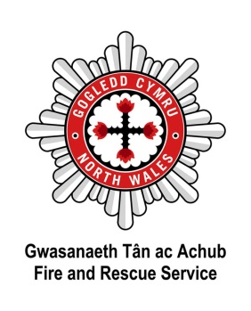
APPLICATION FORM – STRICTLY CONFIDENTIAL Please complete in black ink or type

Application for the post of: Station Manager A B Both | Closing Date: noon 19.06.19
Surname: | Forenames(s):
Address:
Post Code: | Tel Home No:
Mobile No: | Tel No Work:
National Insurance No: | Email Address:
Do you hold a current UK driving licence? Yes No | What type of licence?
Please supply a copy of your driving licence (both photo and paper part) with your application form. Failure to do so may result in your application being discounted.

CURRENT / MOST RECENT POST
Name & Address of Employer | Position Held | Salary/Grade | Date Started | Period of Notice | Reason for Leaving
Please give brief details of your present duties/responsibilities:

PREVIOUS EMPLOYMENT (Please include any periods of unemployment)
Name & Address of Employer | Position Held | Salary | Date Started | Date To | Reason for Leaving

EDUCATIONAL AND OTHER QUALIFICATIONS (Schools/Colleges/University etc)

Date | Subjects | Qualification/Examination | Awarding Body

MEMBERSHIP OF PROFESSIONAL INSTITUTES/BODIES

Name of Institute | Grade | Date

EXPERIENCES/ACHIEVEMENTS
Please give details of your knowledge, skills and experience which you feel are relevant to the requirements of this post and your application. (Please attach a continuation sheet if required).

REHABILITATION OF OFFENDERS ACT 1974 and SAFEGUARDING VULNERABLE GROUPS ACT 2006

Under the provisions of these Acts and Regulations you need not normally disclose details of any “spent” convictions. However, if the post you are applying for involves working with vulnerable adults or children then you must disclose all convictions, cautions, reprimands or final warnings. All posts involving regular contact with vulnerable groups will be subject to an Enhanced Criminal Records Disclosure. All other posts will require a Basic level Criminal Records Disclosure. By signing this application form you are hereby giving consent to undertake the above checks.
Have you been convicted of any criminal offence? (including driving offences) | Yes No
(If Yes, please give details on a separate sheet)

INTERESTS (CLUBS, SOCIETIES, SPORTS, GAMES, HOBBIES ETC)

KNOWLEDGE OF WELSH LANGUAGE – Please tick where appropriate

Are you able to speak Welsh to the standard outlined within the person specification?  Are you able to speak English to the standard outlined within the person specification? | Yes No  Yes No
Are you able to read/write in Welsh to the standard outlined within the person specification?  Are you able to read/write in English to the standard outlined within the person specification? | Yes No  Yes No

ADDITIONAL INFORMATION

Are you related to any employee of North Wales Fire & Rescue Service? If so. Please give details.

Please give any dates in the near future when you will not be available for interview.

REFERENCES

Please give the name and address of two referees, one of which should be your current employer (note we will not contact current employers unless you have been offered a position with North Wales Fire & Rescue Service.) I hereby authorise you to take up references from my previous employer(s), my present employer (once the offer of employment has been confirmed in writing) and any personal referees. In addition, I hereby authorise you to take up other reference checks as you may deem appropriate.
Name & Address | How long and in what capacity has the referee known you
Have you recently received an exit  package from another public body? | Yes |  | Date package received:
 | No

DECLARATION

Canvassing by an applicant of members of the Fire & Rescue Authority either directly or indirectly shall disqualify the candidate concerned for the appointment.
I declare that the statements given on this form are true and accurate to the best of my knowledge and belief and I am not aware of any circumstances, which if known, or become known, to the Fire & Rescue Authority might cause them to question my suitability for appointment.

Signed: | Date:

Where did you see the advertisement?

Thank you for taking the time to complete this application.

The Service will accept application forms by post or email. Please return completed application forms to the address below or via email to HRDesk@nwales-fireservice.org.uk.

Nicola Jones
Human Resources
North Wales Fire and Rescue Service Headquarters
Ffordd Salesbury
St Asaph Business Park
St Asaph, Denbighshire, LL17 0JJ

Applications received after the closing date will not be considered. Please do not submit your CV with your application form, as only the information provided within the application form will be used at the shortlist stage.

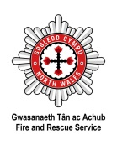

For the attention of HR: To be detached from application form upon receipt

Equalities Monitoring
Name: |  |  |  |  |  |  |  |  | Date of Birth:
Date completed:
Post Applied For:
Fire Service Number: (Internal Application only)
As a public authority North Wales Fire and Rescue Service is required to take steps and aims to promote equality of opportunity and combat discrimination. This information does not form any part of your application and is removed from your application form before submission to the short-listing stage. The information gathered will be used for monitoring, and informing positive action initiatives.
Ethnicity What is your ethnic group?
White |  |  |  |  |  |  | Mixed/multiple ethnic groups
 | British |  |  |  |  |  |  | White and Black Caribbean
 | Welsh |  |  |  |  |  |  | White and Black African
 | English |  |  |  |  |  |  | White and Asian
 | Scottish |  |  |  |  |  |  | Do not wish to state
 | Irish/Northern Irish |  |  |  |  |  |  | Other please specify below:
 | Gypsy or Irish Traveller
 | Do not wish to state
 | Other please specify below: |  |  |  |  |  | Asian/Asian British
 |  |  |  |  |  |  |  | Indian
 |  |  |  |  |  |  |  | Pakistani
Black/African/Caribbean/Black British |  |  |  |  |  |  |  | Bangladeshi
 | African |  |  |  |  |  |  | Chinese
 | Caribbean |  |  |  |  |  |  | Do not wish to state
 | Do not wish to state |  |  |  |  |  |  | Other please specify below:
 | Other please specify below:
 |  |  |  |  |  |  | Any other Ethnic Group
 |  |  |  |  |  |  |  | Other please specify below:
Sex and Sexual Identity:
Sex: What is your sex? |  |  |  |  |  |  | Sexual Identity: which best describes how you think of yourself?
 | Female |  |  |  |  |  |  | Heterosexual/Straight
 | Male |  |  |  |  |  |  | Gay/Lesbian
 |  |  |  |  |  |  |  | Bisexual
Gender Identity: Which of the following describes how you think of yourself? |  |  |  |  |  |  |  | Do not wish to state
 | Female |  |  |  |  |  |  | Other please specify below:
 | Male
 | In another way
 | Not applicable
 | Do not wish to state

Disability and Marriage or Civil Partnership
Disability
North Wales Fire and Rescue Service operate an Interview Guarantee Scheme for candidates with disabilities (Two Ticks). This means that any job applicant, who has a disability and meeting the essential job requirement set out in the person specification, will be invited to the selection process/interview. A disability is defined under the Equality Act 2010 as a physical or mental impairment, which has a substantial long-term adverse impact on a person’s ability to carry out normal day-to-day activities.

Marriage or Civil Partnership Same Sex Couples
Civil partnerships in the United Kingdom, granted under the Civil Partnership Act 2004, allow same-sex couples to obtain essentially the same rights and responsibilities as civil marriage.

The Marriage (Same Sex Couples) Act 2013 legalised full same-sex marriage starting from March 2014, although civil partnership also remains available.

Disability |  |  |  | Marriage or Civil Partnership
Do you have a long-standing physical or mental health condition or disability? By long standing, we mean anything that has lasted or is likely to last at least 12 months. |  |  |  | What is your legal marital or same-sex status? |  | Opposite Sex | Same Sex
 | Physical Impairment |  |  | Married
 | Sensory Impairment |  |  | Living with a partner
 | Mental Health condition |  |  | Registered Civil Partnership
 | Long standing illness or health condition
 |  |  |  | Single
 | Other such as disfigurement |  |  | Widowed
 | Learning Disability |  |  | Separated
 | Do not wish to state |  |  | Divorced
 | None |  |  | Do not wish to state
National Identity and Religion
National Identity: |  |  |  | Religion: What is your religion?
 | British |  |  |  | No Religion
 | Welsh |  |  |  | Christian (All denominations)
 | Scottish |  |  |  | Buddhist
 | English |  |  |  | Hindu
 | Irish/Northern Irish |  |  |  | Jewish
 | Do not wish to state |  |  |  | Sikh
 | Other please specify below: |  |  |  | Muslim
 |  |  |  |  | Do not wish to state
 |  |  |  |  | Other please specify below:

Official Use Only:
Date entered on Workforce

